A Higher State  
  
Final Documentation

Shahbegh Singh Kalra

N241  
 04/26/2017  
  
  
  
  
  
  
  
  
  
1)The Plan:

Purpose:  
  
 The purpose of my website is that it is a showcase of my hobby i.e. Meditation and since I've been researching a lot on this topic, I want to share the facts, benefits, ways to practice it and resources with the people who share the same hobby and want to progress in this field. The site will also provide information on the topics which most of the websites don't provide as much.

Needs Analysis:  
 This site will have the following pages and will be providing information in the following areas-

1)The Science of Meditation  
2)How to meditate

3)Guided Meditation

4)Benefits of Meditation

5)Contact Us

Goals:

1)To provide resources and material through which the user can reap the benefits of meditation.

2)Spread awareness of this excellent practice .  
  
3)To update the followers on the new research in this topic

###### Audience Characteristics:

The two kinds of audience that will be visiting this website are-  
1)Beginners in this field.  
2)People who are progressing in this field of meditation and have been practicing it for a while.

i) Primary Audience:

The people who have made meditation a part of their life, practice it daily and need the tutorials in order to update themselves will be the primary audience .Since updates will be available often, it will be really beneficial for the primary audience to keep progressing .

ii) Secondary Audience:

Adults, Children or Adolescents who want to learn and develop this art and are new to this will be considered as the secondary audience. For these people, beginner tutorials will also be available since they would be new to this and in this way, they won't miss out the initial training.

###### Competition:

The competing websites that i found on the internet are-

1)Meditation mount: https://meditationmount.org/?gclid=CMKmkIrQpNMCFc64wAodNagMUA

i)This website has light colors which are pleasing to the eye  
ii)Images resized to equal dimensions which are arranged in tabular layout  
iii) Three column layout in the footer  
iv)A navigation map and an event menu which provides information to the user and is really convenient to the user.  
  
1)Turning within:  
http://www.turningwithin.org/  
  
i)The website has all elements aligned at the center  
ii)Also, they used two column layout which looks good when the other elements are aligned at the centre  
iii)They have a video element which describes more about their website  
iv)The form page has tabular layout which increases readability of the form.

2)Wire Frame:

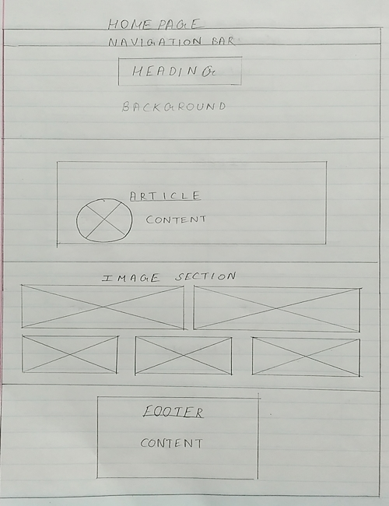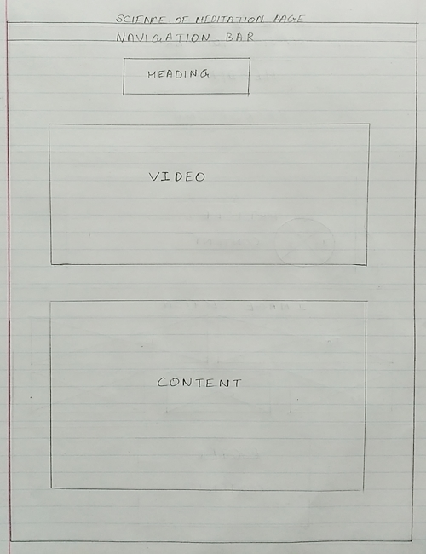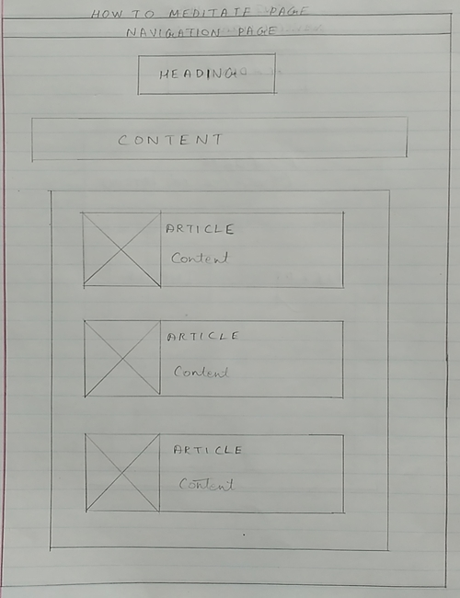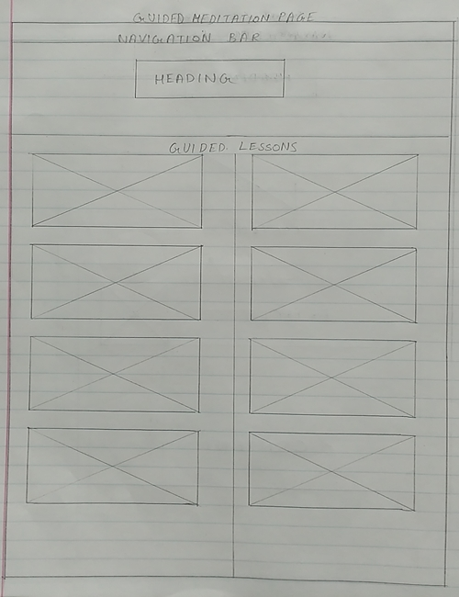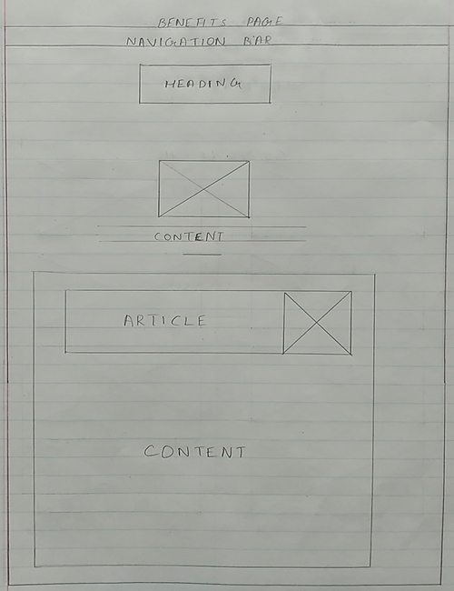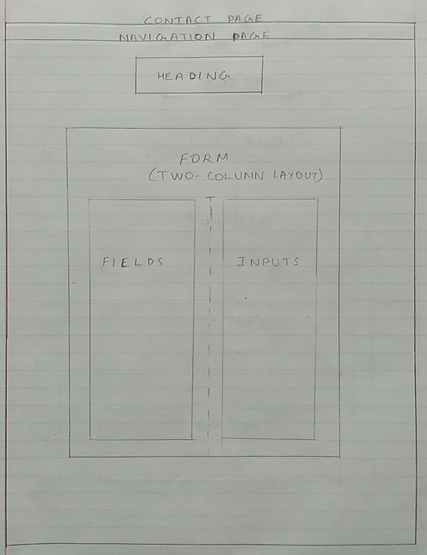

3)Site Map

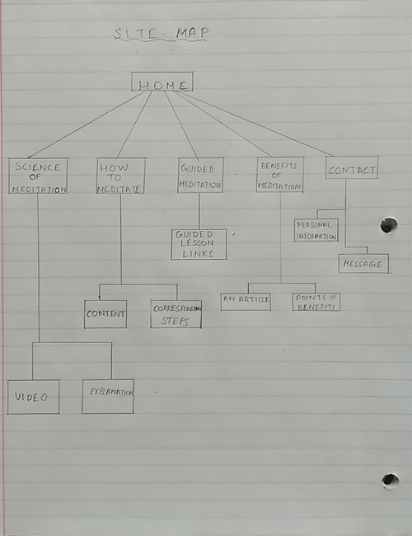

4)Best Viewed Assumptions:

**Browser Type/Version:** The web pages are best viewed in the most recent version of Google Chrome . The majority of the testing of web pages was conducted in Google Chrome and some testing was done in Internet Explorer and Microsoft Edge. All three showed similar results with minor differences.

**Connection Speed:** A good internet speed would be ideal. Though, there are many images in the website, most of them were optimized so that they take less space and the web page runs quite fast.

**Screen Size:** The resolution of the images will be optimal for 15" monitors, Alignment of some absolutely positioned elements would suffer if it is viewed on a larger screen.

5)Test Plan:

### *Validation:*

The css page validated right in the first go but the html page gave many errors and warnings in the beginning, major of which were stray tags,img alt attributes,element cannot be descendent of a particular element and warnings included putting header for the section field and specifying the en(english) language in html tags. These all errors and warnings have been fixed now and both the html and css pages validate.

### *Flexibility:*

Most of the pages have flexible content.Few of the issues that I have are with the navigation bar and main headings since they are absolutely positioned on the relative background image so, resizing the page gave issues with these things. The images are fixed size so, on shortening the window,they go out of their sections. Most of the issues have been fixed but using auto margin property.

### *Speed:*

I tested the speed on https://gtmetrix.com/ page and here are the results-  
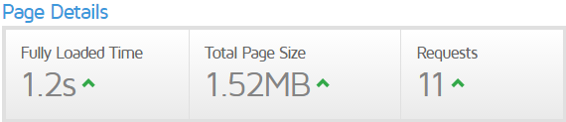  
The images weren't optimized and weren't compressed so, the result, wasn't too good but the website recommended to use progressive jpegs to optimize time. Also, before correcting the errors and warning, the time of execution was more but after correction, the execution time reduced significantly.

### *Accessibility:*

For the accessibility part, I tested my site on http://www.cynthiasays.com/. Few of the results that I got were -

Organize documents so they may be read without style sheets.

Ensure that all information conveyed with color is also available without col...

### *Browser Independence:*

I tested my website on the following browsers-

Google Chrome

Microsoft Explorer

Microsoft Edge

Nearly all the results were same except for the list item in one of the page where the list-style-type were presented well in chrome but were shifted towards left in edge and explorer.

6)Post-Project Analysis:

Revised Parts:

I revised the parts of this project which were mainly absolutely positioned since I had issues with those elements which resizing the page. I did fix the Headings which were absolutely positioned.

Things learned:

I learned a lot from this Project. My common mistakes such as not adding heading to sections , articles etc. were repetitive which made me learn from it. Also, I learned about the descendant properties like which element can have other element as child and which ones cannot.   
  
Working:

The website runs well on major browser such as Chrome, Explorer and Edge.  
The parts that work well on Chrome is that of my list-style-types which for some reason float on the left in explorer and edge, the reason for which I think is because of their old versions(since it works n Chrome).  
Another thing that works on Internet Explorer and Microsoft Edge but not on Chrome is the video.  
I tried putting many more source elements with different format for chrome but still chrome doesn't play the video.

7)Project Checklist:

External Stylesheet: <http://cs.iupui.edu/~sskalra/n241/css/final.css>  
Embedded Stylesheet: <http://cs.iupui.edu/~sskalra/n241/final/guided.html#embed>  
Css Style Comment: <http://cs.iupui.edu/~sskalra/n241/css/final.css>

Example of overwritten style: <http://cs.iupui.edu/~sskalra/n241/final/home.html#override>

Header Comment: <http://cs.iupui.edu/~sskalra/n241/final/home.html#comment>

Example of a <table>: <http://cs.iupui.edu/~sskalra/n241/final/guided.html#myTable>

Example of a<blockquote>: <http://cs.iupui.edu/~sskalra/n241/final/science.html#bQuote>

Example of an <ol> list: <http://cs.iupui.edu/~sskalra/n241/final/how.html#oList>

Example of a <ul> list: <http://cs.iupui.edu/~sskalra/n241/final/how.html#uList>

Example of a <dl> list: <http://cs.iupui.edu/~sskalra/n241/final/benefits.html#dList>

Example of PNG: <http://cs.iupui.edu/~sskalra/n241/final/guided.html#png>  
Example of JPG: <http://cs.iupui.edu/~sskalra/n241/final/home.html#jpg>

Example of a <form>: <http://cs.iupui.edu/~sskalra/n241/final/contact.html#myForm>  
Example of typography: <http://cs.iupui.edu/~sskalra/n241/final/home.html#coolFont>  
Example of a css rollover effect: <http://cs.iupui.edu/~sskalra/n241/final/guided.html#roll>

EXTRA CREDIT NOT INCLUDED

8)Bibliography:

Head First HTML with CSS :Used for a majority of CSS styling tips and this was the primary resource.

The World Wide Web Consortium: https://www.w3.org/ Used for a number of minor fixes such as correcting syntax, tag references, to remove warnings.  
  
 Online website layout resources used were http://www.creativebloq.com/ and www.webdesignerdepot.com to learn the Wire Frame.  
  
http://www.yogajournal.com/ and www.artofliving.org were used to refer to styling and understand the structure of an interactive website.

User interface articles used were https://www.w3schools.com/ , https://css-tricks.com/ and http://www.uxbeginner.com/

Images:

Home:







Science of Meditation:



Benefits:



Guided meditation:

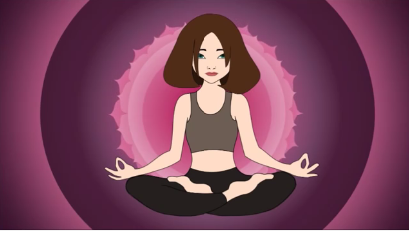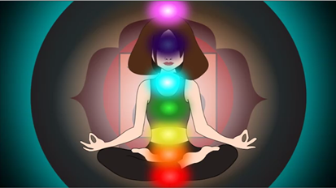

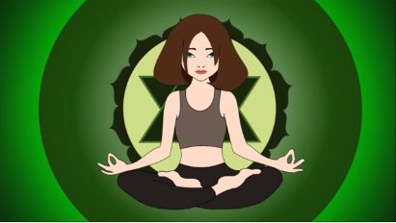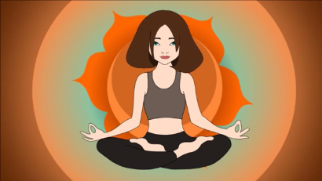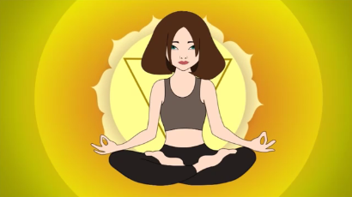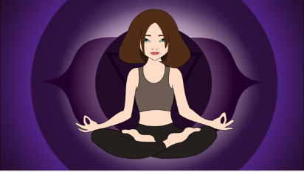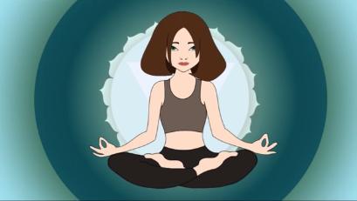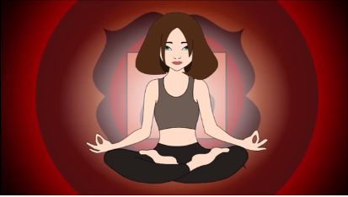



How to Meditate:

